**Webhook Reference – V1.2**

As a validated partner of Endurance Zone Rewards, you are able to manage your subscribed members in the rewards application.

You are able to set a new member with a member level of either ‘Basic’, ’Premium’ or ‘Premium Plus’. Within the application, for each of these member levels you can manage which rewards are available to which member levels. If you only require one member level of pricing and functionality, use ‘Basic’ as your default MemberLevel.

**Testing Environment**

The Endpoint URL for testing this rest service in our Sandbox is:

<https://rewards.endurancezone.com/AwareIM/REST/Sandbox/PartnerMember>

After successful testing you should switch to the production Endpoint URL which is referenced below.

**New Member**

A new member is created by submitting a request to our endpoint including all required information.

Request:

|  |  |
| --- | --- |
| Endpoint URL | https://rewards.endurancezone.com/AwareIM/REST/EzRewards/PartnerMember |
| Parameters: | *Note: all parameters below are required |
| API_Key* | (Provided to you) |
| FirstName* |  |
| LastName* |  |
| EmailAddress* |  |
| Country* | (Acceptable Values: Canada, USA, UK) |
| Type* | **New** (Acceptable Values: New,Renewal,Cancel, Manage) |
| MemberLevel* | (Acceptable Values: Basic, Premium, Premium Plus) |

Successful Response:

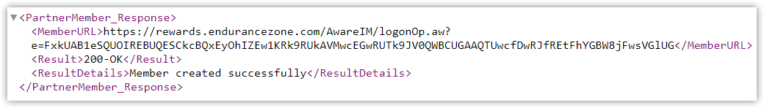

The resulting MemberURL is provided in the response. You should parse this response to extract this string and place it in your website or app to allow member to access Endurance Zone Rewards account.

Failed Response:

Any resulting error such as an incorrect or missing API_Key or missing required field will be presented with a result of ‘400- NOT OK’ and the ResultDetails will provide you with error details.

Here is an example url submission:

https://rewards.endurancezone.com/AwareIM/REST/EzRewards/PartnerMember?API_Key=[ENTER YOUR API_Key HERE][&FirstName=Test&LastName=Member&EmailAddress=test@test.com&Country=UK&Type=New&MemberLevel=](mailto:&FirstName=Test&LastName=Member&EmailAddress=test@test.com&Country=UK&Type=New&MemberLevel=)Premium

**Member Subscription Renewal**

A member subscription renewal is created by submitting a request to our endpoint including all required information. The renewal request is identical to the new member request except the type must be set to ‘Renewal’ instead of ‘New’.

Renewing a subscription will set the renewal date to 365 days from the current date and will set the member status to ‘Active’.

Request:

|  |  |
| --- | --- |
| Endpoint URL | https://rewards.endurancezone.com/AwareIM/REST/EzRewards/PartnerMember |
| Parameters: | *Note: all parameters below are required |
| API_Key* | (Provided to you) |
| FirstName* |  |
| LastName* |  |
| EmailAddress* |  |
| Country* | (Acceptable Values: Canada, USA, UK) |
| Type* | **Renewal** (Acceptable Values: New,Renewal,Cancel,Manage) |
| MemberLevel* | (Acceptable Values: Basic, Premium, Premium Plus) |

Successful Response:

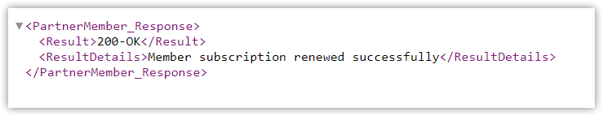

Failed Response:

Any resulting error such as an incorrect or missing API_Key or missing required field will be presented with a result of ‘400- NOT OK’ and the ResultDetails will provide you with error details.

Here is an example url submission:

https://rewards.endurancezone.com/AwareIM/REST/EzRewards/PartnerMember?API_Key=[ENTER YOUR API_Key HERE][&FirstName=Test&LastName=Member&EmailAddress=test@test.com&Country=UK&Type=Renewal&MemberLevel=Basic](mailto:&FirstName=Test&LastName=Member&EmailAddress=test@test.com&Country=UK&Type=Renewal&MemberLevel=Basic)

**Manage Member**

Member details can be edited created by submitting a request to our endpoint including all required information. The manage request is identical to the new member request except the type must be set to ‘Manage’ instead of ‘New’

When a member manage request is received, if a member exists with a matching login, that record will be updated to reflect the submitted information. The fields that are updated are:

* First Name
* Last Name
* MemberLevel

Managing members would typically be used to upgrade or downgrade a Member level i.e. Basic -> Premium, Premium -> Premium Plus, Premium -> Basic etc…

Request:

|  |  |
| --- | --- |
| Endpoint URL | https://rewards.endurancezone.com/AwareIM/REST/EzRewards/PartnerMember |
| Parameters: | *Note: all parameters below are required |
| API_Key* | (Provided to you) |
| FirstName* |  |
| LastName* |  |
| EmailAddress* |  |
| Country* | (Acceptable Values: Canada, USA, UK) |
| Type* | **Manage** (Acceptable Values: New,Renewal,Cancel,Manage) |
| MemberLevel* | (Acceptable Values: Basic, Premium, Premium Plus) |
| NewEmailAddress | (Optional) |

If you wish to change the email address of a member, the new email address should be added as an optional parameter titled ‘NewEmailAddress’. FirstName,LastName and MemberLevel can be changed directly in the submitted parameters.

Successful Response:

**Member Subscription Cancellation**

A member subscription cancellation is created by submitting a request to our endpoint including all required information. The cancel request is identical to the new member request except the type must be set to ‘Cancel’ instead of ‘New’

Request:

|  |  |
| --- | --- |
| Endpoint URL | https://rewards.endurancezone.com/AwareIM/REST/EzRewards/PartnerMember |
| Parameters: | *Note: all parameters below are required |
| API_Key | (Provided to you) |
| FirstName |  |
| LastName |  |
| EmailAddress |  |
| Country | (Acceptable Values: Canada, USA, UK) |
| Type | **Cancel** (Acceptable Values: New,Renewal,Cancel,Manage) |
| MemberLevel | (Acceptable Values: Basic, Premium, Premium Plus) |

Successful Response:

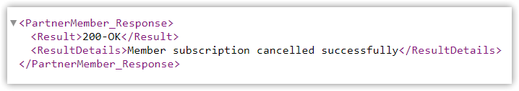

Failed Response:

Any resulting error such as an incorrect or missing API_Key or missing required field will be presented with a result of ‘400- NOT OK’ and the ResultDetails will provide you with error details.

Here is an example url submission:

https://rewards.endurancezone.com/AwareIM/REST/EzRewards/PartnerMember?API_Key=[ENTER YOUR API_Key HERE][&FirstName=Test&LastName=Member&EmailAddress=test@test.com&Country=UK&Type=Cancel](mailto:&FirstName=Test&LastName=Member&EmailAddress=test@test.com&Country=UK&Type=Cancel)&MemberLevel=Basic